Requirements:
1
- Basic knowledge on embedded system and network concept.
- Telnet application (PuTTy is recommended)
- TFTPD server (TFTPD32 is recommended)

Instructions:
- Make sure THE DEVICE is not powered on. But keep the network cables connected to THE DEVICE and your PC/Notebook.

- Configure your local computer IP address to 192.168.1.11(with network interface down).

- Run putty.exe. Set host IP to 192.168.1.1 and port to 9000. Do not click on <Open> yet.
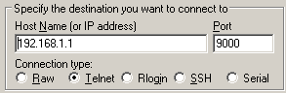
The following procedure is time sensitive. You may need to try several times to actually login into the bootloader. Please follow the instructions closely and catch the right timing for the action.

- Whenever the device is powered on, there are 2 seconds timeout before initiating boot. That is, we need to login into the device bootloader in this short period of time.
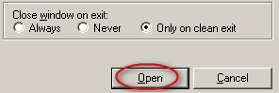
- Now, keep your mouse pointer right over the <Open> button. DO NOT CLICK ON IT YET.

- Plug in the adaptor head into your PoE DC-IN and monitor your network status closely to the transition from to .

- When network interface is up , click on <Open>. When you see the terminal window pops up, press <CTRL + C> and press <Enter>.

Note: Everything should be done in 2 seconds. Once your see RedBoot> prompt that means you have succeeded. If not, you will have to repeat step 5 and 6 again until RedBoot prompt appears.
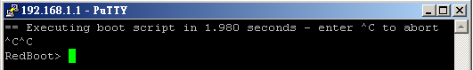

2
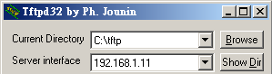
- Run Tftpd32 and configure Current Directory to C:\tftp and Server interface to 192.168.1.11.

- Copy linux.bin (DD-WRT firmware) to TFTP server directory C:\tftp.

- Switch to PuTTy terminal window and type in commands as follows.

- Configure the bootloader IP and TFTP server IP address:
RedBoot> ip_address -l 192.168.1.1 -h 192.168.1.11

- Flash the unit:
RedBoot> fis init
About to initialize [format] FLASH image system - continue (y/n)? y
*** Initialize FLASH Image System
... Erase from 0xa87e0000-0xa87f0000: .
... Program from 0x80ff0000-0x81000000 at 0xa87e0000: .

- Download the image from TFTP server and copy into memory
RedBoot> load -r -b 0x80041000 linux.bin
Using default protocol (TFTP)
-
Raw file loaded 0x80041000-0x80663fff, assumed entry at 0x80041000

- Create a partition in flash
RedBoot> fis create linux
Note: This step will take about 10~15 minutes to complete, please wait patiently.
... Erase from 0xa8030000-0xa8653000: .....................................
... Program from 0x80041000-0x80664000 at 0xa8030000: .................
... Erase from 0xa87e0000-0xa87f0000: .
... Program from 0x80ff0000-0x81000000 at 0xa87e0000: .

3
- Write bootscript into bootloader
RedBoot> fconfig boot_script true
boot_script: Setting to true

RedBoot> fconfig boot_script_data
boot_script_data:
Enter script, terminate with empty line
>>fis load -l linux
>>exec
Update RedBoot non-volatile configuration - continue (y/n)? y
... Erase from 0xa87e0000-0xa87f0000: .
... Program from 0x80ff0000-0x81000000 at 0xa87e0000: .

- Reboot the device (you may need to power cycle)
RedBoot> reset

- Now you have successfully loaded DD-WRT firmware into THE DEVICE. Please configure your network interface to “Obtain an IP address automatically”.

- You will be given 24hrs trial period. You can buy Activation License from the official web site at http://www.dd-wrt.com/shop/catalog/

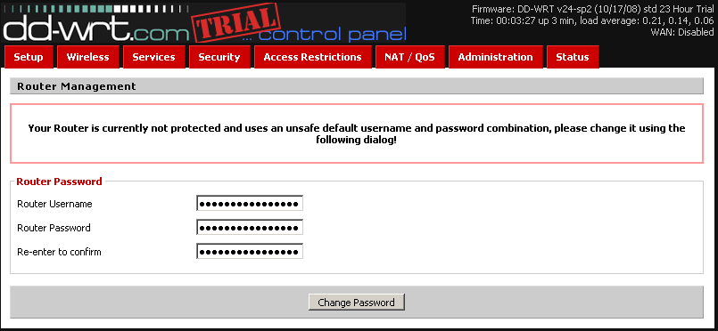



4

- Once license is bought, you can get an Activation Key by entering the System Key (which can be found under Status Tab) on DD-WRT web site.

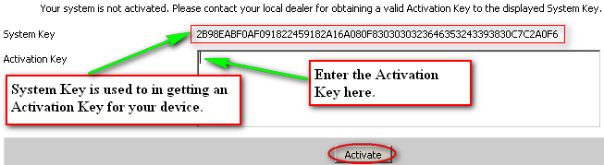

DD-WRT Compatible Products:
EOC-2610 | EAP-3660 | EOC1650
EOC1630 | ECB3500 | EOA3650

Notice:
DD-WRT is a popular and widely accepted software platform. Porting DD-WRT is considered safe given that you are familiar with the technical details but do so at your own risk.Please be informed that it is irreversible once the firmware is overwritten.

